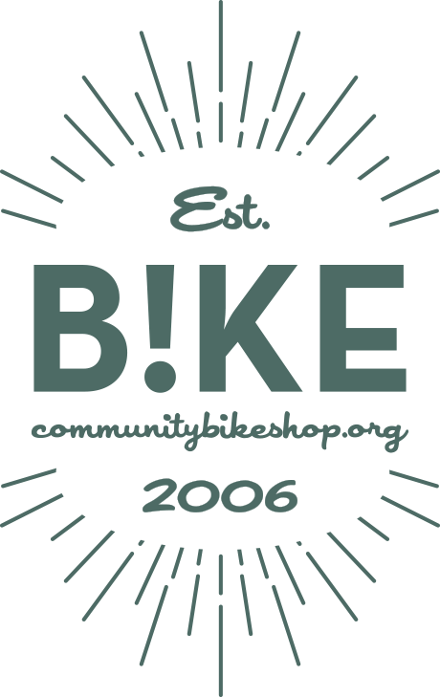Job Description:

Board Director

**B!KE: The Peterborough Community Bike Shop**

293 George Street North

Peterborough, Ontario

K9J 3H3

[www.communitybikeshop.org](http://www.communitybikeshop.org/)

[BoardChair@communitybikeshop.org](mailto:boardchair@communitybikeshop.org)

Updated: June 16, 2025

# Position Overview

B!KE is an incorporated not-for-profit organization that supports cycling in the greater Peterborough area. Operating in the community since 2006, we support cyclists by: delivering maintenance, repair and safe riding education, consulting on infrastructure, advocating for bike-friendly communities, and by cultivating a supportive cycling community at our open shop facility downtown.

If you are an avid cyclist and want to help shape the future of cycling as an important mode of transportation in the greater Peterborough area, we would love to hear from you.

Although no prior board experience and/or non-profit experience is required, we are looking for board members with backgrounds in finance, legal, fundraising, sales/marketing and information systems.

The board director position is a volunteer, non-paid position.

# Position Details

**Purpose of the Position**

Under the leadership of the chair and board executive - including the treasurer and secretary - the B!KE Board provides direction and guidance to B!KE’s executive director in accordance with the Ontario Not-for-Profit Act and B!KE’s bylaws and policies.

**Terms**

Following details laid out in the B!KE board manual, the board of directors:

* Serve on B!KE’s board for a minimum of period of two (2) years
* Attend monthly board meetings (excluding summer break) either in person or online
* Are willing to join a board sub-committee including finance, governance, fundraising, and others as decided by the board of directors
* Fulfil general fiduciary responsibilities through a regular review of B!KE’s governance documents
* Fulfil a timely review of strategic, financial, and human resources reports, and necessary accompanying documents for board meetings and board decisions
* Engage actively, with responsibility and in good faith, in discussions of importance related to B!KE’s governance, purpose, and direction

**Of Additional Note**

We recommend board members maintain an active B!KE membership status, and when able, consider donating to the organization as an indication of your commitment to its value to our community.

All Board Directors will be privy to confidential and privacy information and are required to maintain that confidentiality at all times.

**Equal Opportunity**

B!KE is committed to employment equity and diversity in the workplace and welcomes applications from women, visible minorities, aboriginal people, persons with disabilities, and persons of any sexual orientation or gender identity.

|  |
| --- |
| **IF INTERESTED, PLEASE EMAIL LES KARIUNAS, BOARD CHAIR AT** [boardchair@communitybikeshop.org](mailto:boardchair@communitybikeshop.org) |